Laboratory 1 – Week 1
An Introduction to Java and Eclipse

Introduction

This worksheet is a short session to familiarise you with the Java and Eclipse programming and development environment. This laboratory involves writing your first program from scratch, importing an existing project, making some changes and exporting it again.

Preliminaries

Make sure you have access to your home directory (we will assume this is the H:\ drive). Eclipse (on campus machines) should create a place for all of your workspaces in H:\eclipseWorkspace. Check that this is the case.

Starting Eclipse

If you want to install Eclipse on your own computer (this is highly recommended) then you can do so from http://www.Eclipse.org. Here you can download the version of Eclipse you are after (we suggest the 32 bit or 64 bit Eclipse IDE for Java Developers). You need the same number of bits (32 or 64) as your installed version of the Java runtime libraries which can be found at http://www.Java.com. This website will also determine if your computer has Java installed or not. If you are not sure if you need the 32 or 64 bit versions of Java and Eclipse, then see if the 64 bit version works. Note that any version you download from the Eclipse website might be slightly different to the versions that we are running on the department machines, but all of the concepts should be the same.

On the department machines, Eclipse can be found by searching for the word Eclipse through either the Windows 10/11 button or the Windows 10/11 Search button.

This program works similar to any other software product, i.e. you open up the program, and you then either create a new program or load an existing program. When you have finished, you exit Eclipse by selecting File-Exit.

Eclipse and Java

Within this module we will be using the Eclipse to develop our Java programs. We will cover this in more later during the Java programming module, however, to start with, please look at (and read) the links in Table 1.

Link | Notes
http://en.wikibooks.org/wiki/Computer_Programming | What is computer programming?
http://math.hws.edu/javanotes/ | An online free Java book
https://www.softwaretestinghelp.com/eclipse/ | Beware this site contains adverts!
http://www.vogella.com/tutorials/Eclipse/article.html | Eclipse IDE tutorial (an older version but most of the material is similar)
Table 1: Java and Eclipse Links

Getting Started

A computer program (written in a programming language) can be thought of as a text file containing a list of instructions for a computer to carry out. Similar to a spoken language, computer languages have syntax and structure. A badly formed/written computer program will not be understood by a computer. Java is an example of a programming language. As with any form of Office computer document, we need a special piece of software to write computer programs. We usually use a type of software called an Integrated Development Environment (IDE); Eclipse is a professional standard IDE that we will be using for writing Java programs.

Start Eclipse by selecting the Windows button on the Windows task bar (or press the Windows button) and look for Eclipse by typing Eclipse. Run (click/select) Eclipse Desktop app. You should eventually see a Window that looks something like this:
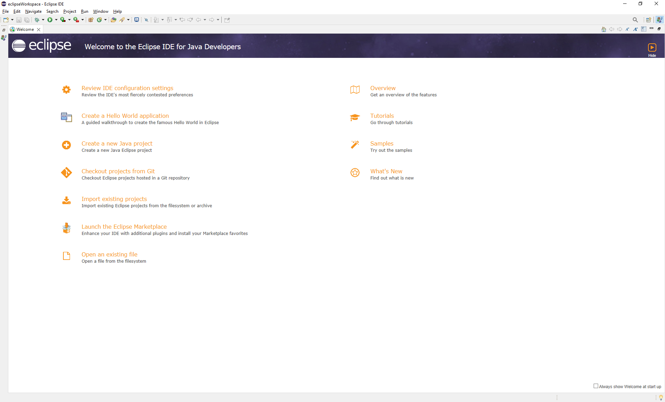

By default on a University machine, Eclipse should create a directory on your H:\ drive called H:\eclipseWorkspace, this is where your Java programs will be created. Check that this is the case. If you are doing this on your own machine, then the first time you run Eclipse you will be prompted for your workspace location. We suggest your H:\ drive as above (if you can connect to it).

Closing the welcome screen should result in the following:

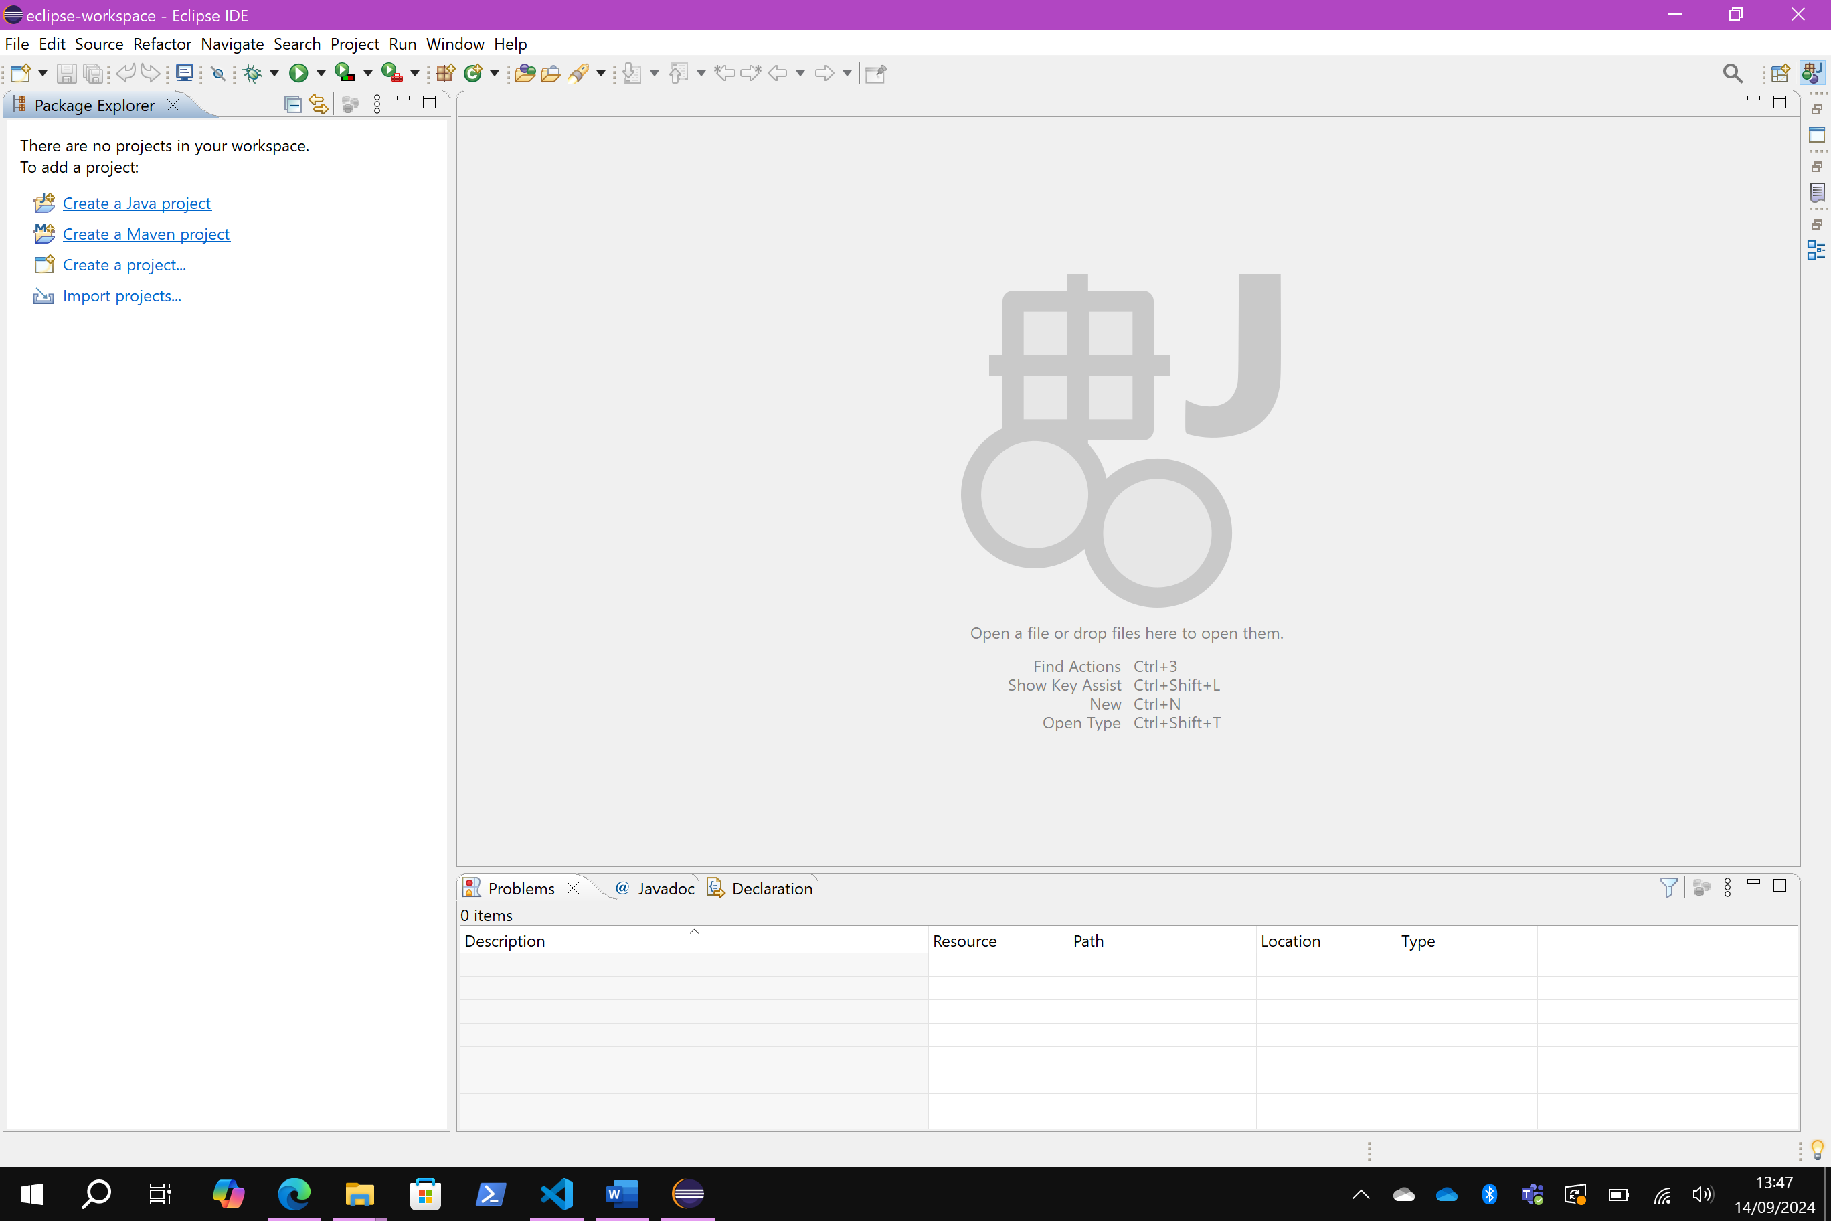

Close the “Donate” and “Outline” sub-windows if they are open.

To create a Java program, select from the Eclipse menu bar “File” then “New” and then “Java Project” you should get the following:

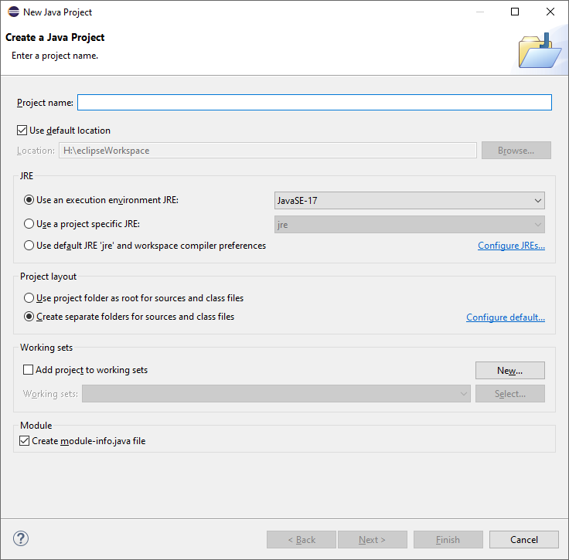

In the project name field type “CS1603”. This is the name we are going to give to your Java program. If any dialog boxes pop up asking you about “Open Associated Perspective” and/or “Android SDK” click yes or proceed as appropriate. Do not worry about these at the moment. Uncheck “Create module-info.java file”.

Click finish and your (empty) project should be created and appear in the “Package Explorer” in the left hand pane of Eclipse. If it doesn’t show automatically, you “Restore” the window by clicking on the two window icons.

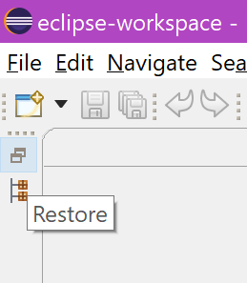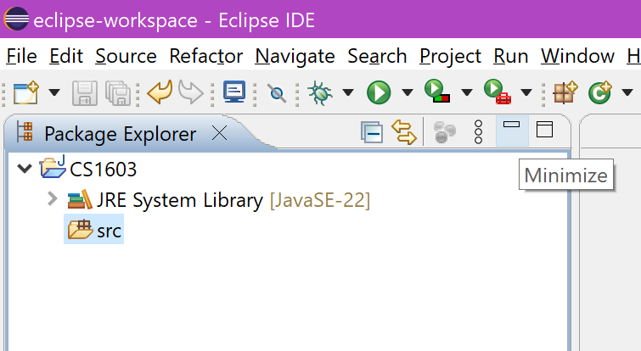

Open up the new project that you have created by clicking the prompt (>) at the side of project “CS1603”. In the src, right click New and create a Class. In the prompt, enter “Lab1” as the class name.

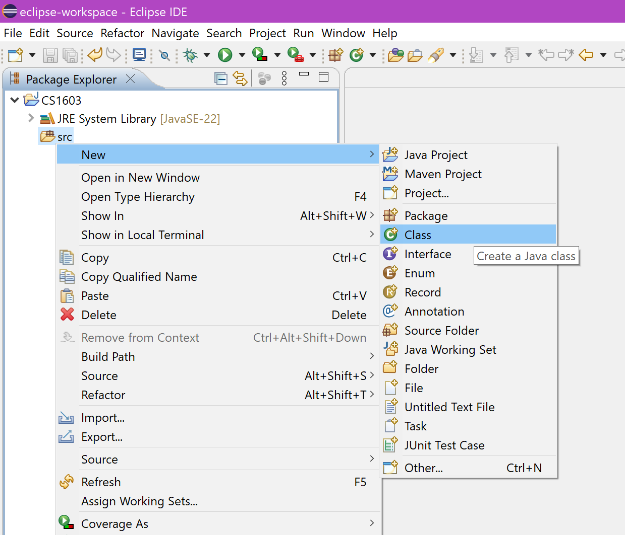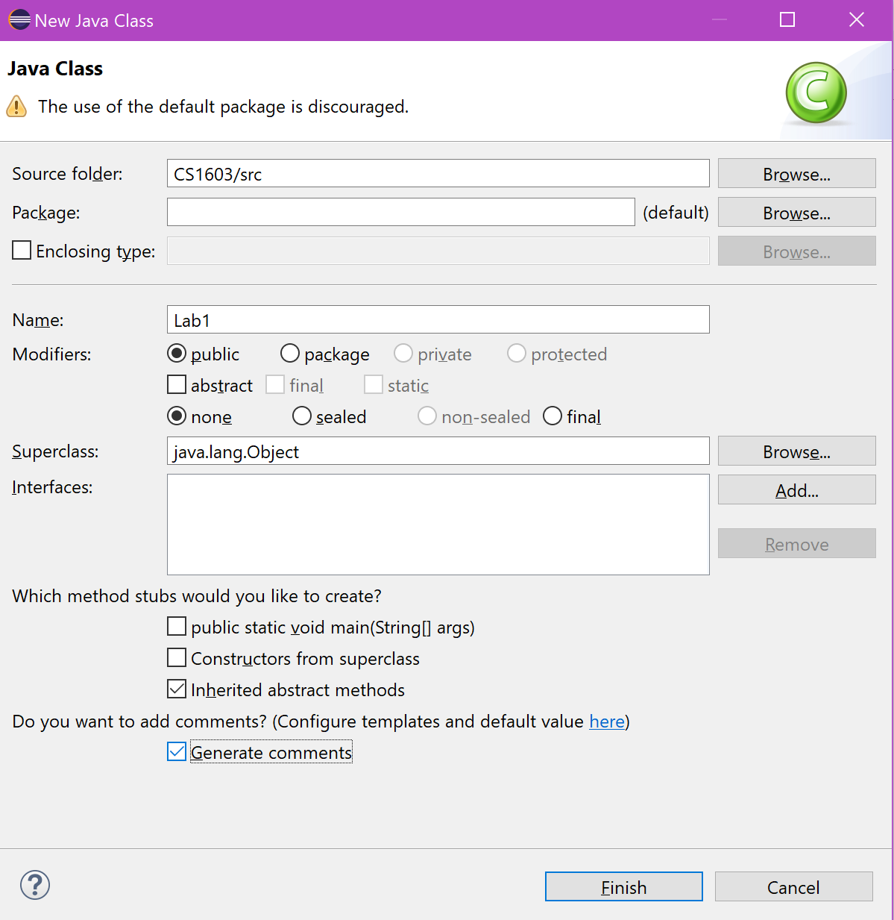

You should get the following:

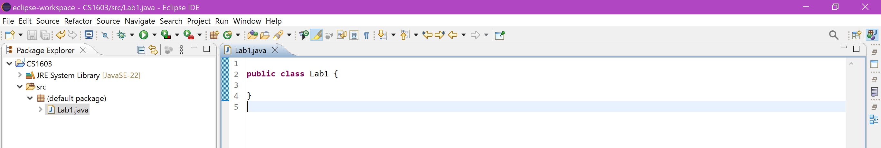

Java and the Eclipse IDE

The components of the Eclipse IDE that we will be working with are as follows:

Workspace. As discussed previously, the default Workspace location is H:\eclipseWorkspace. You can change your Workspace to any directory you wish, however you will not be able to access the projects/programs from the previous Workspace.

Package Explorer. As seen above, this is a list of all of the projects (programs) you have created in the selected/current Workspace and is positioned in the left hand pane of Eclipse. All of the projects will be listed here in alphabetical order. Expanding the project name will give you access to the source code (within src and the (default package)).

Console Window. Any output generated by your programs will be displayed in this Window which is positioned in the bottom middle pane of Eclipse.

(If it doesn’t show, click on Window > Show View > Console)


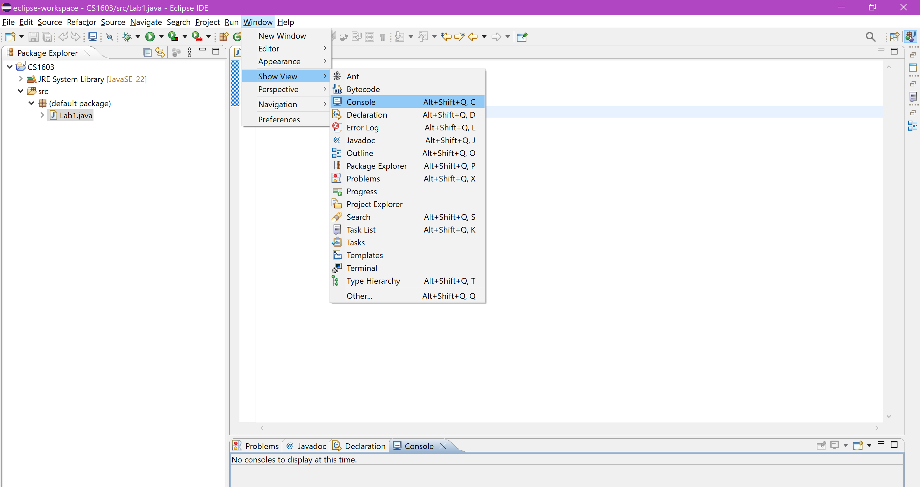

Javadoc Window. This pane appears in various parts of the IDE and gives you context sensitive help pages on some of the aspects of Java. We will look at this later on in this worksheet.

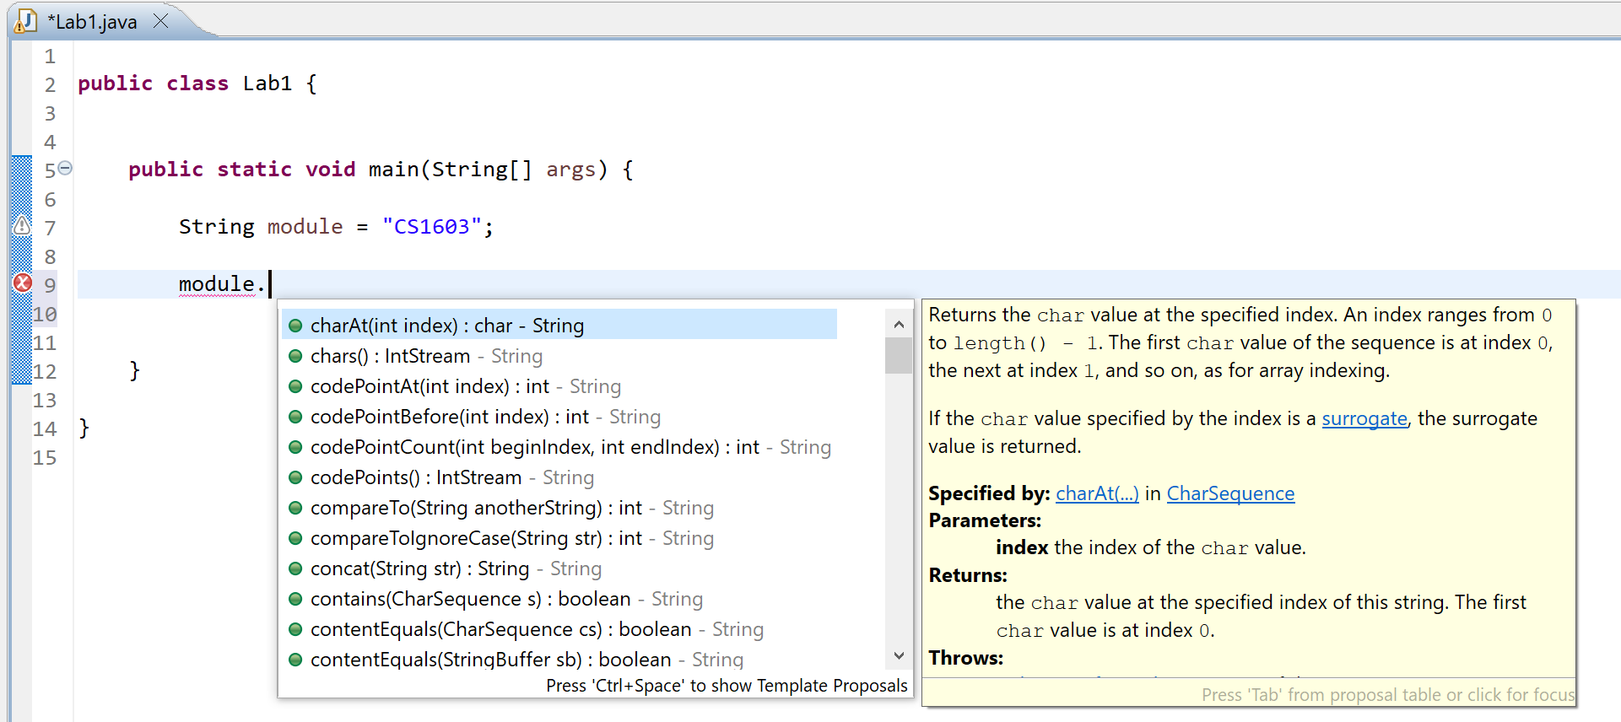

If you close any of the panes within Eclipse and then find you need them again, you can reopen them as shown earlier by using the Eclipse menu option Window and then Show View.

Exit Eclipse and open up Windows Explorer and find the following directory H:\eclipseWorkspace\CS1603\src. You can also directly navigate to this folder by right clicking on the Java class we created earlier going to “Show In” > “System Explorer”.

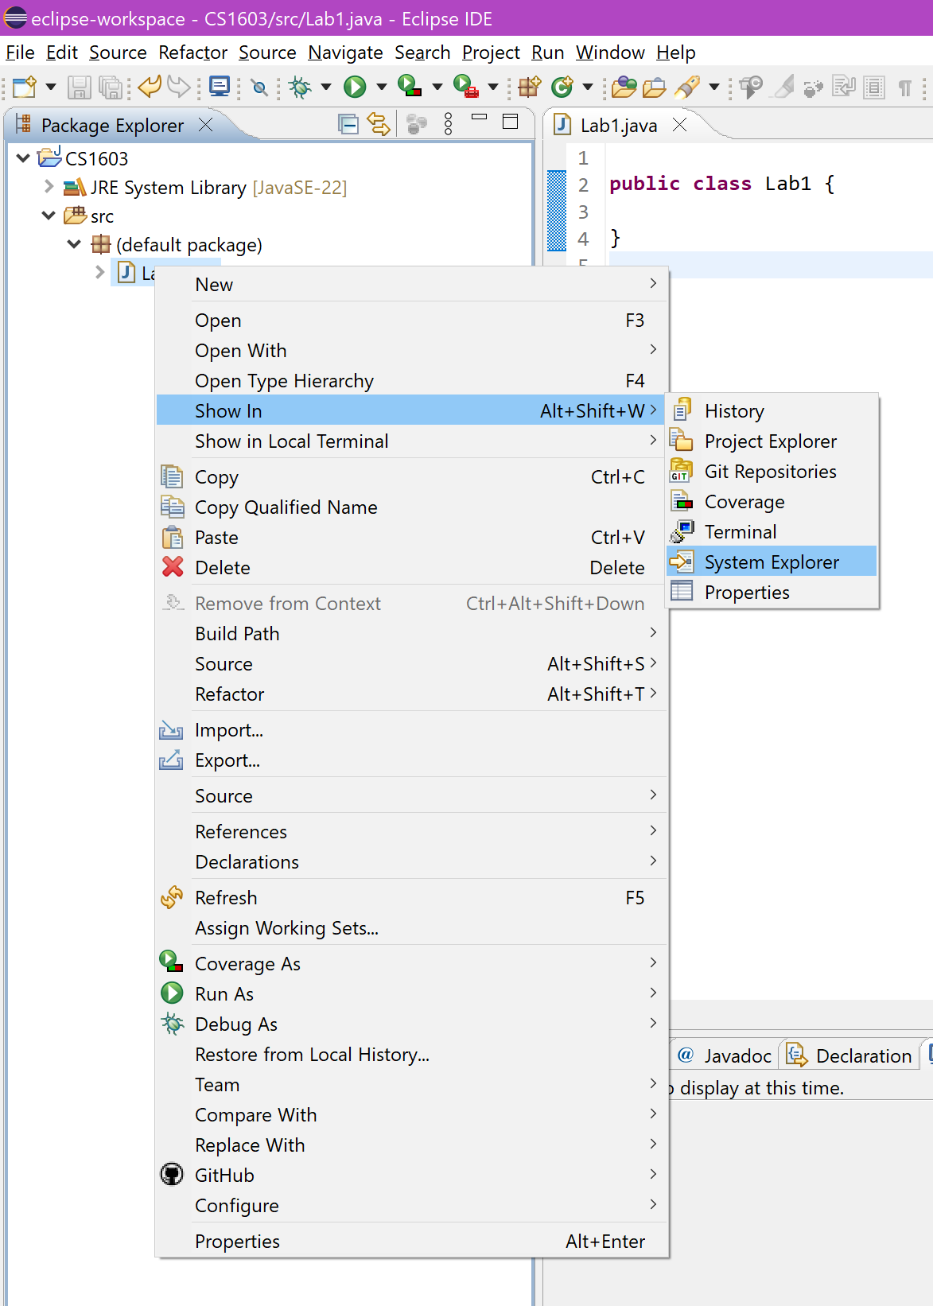

This assumes that you have placed your projects in the H:\eclipseWorkspace directory. Open up the file called Lab1.java using Notepad. This is the source code of your new project/Java program and should match the program that you saw in the Eclipse main window. Source code files are simply text files with a .Java extension (of course they must also contain Java code!). All of the other files placed by Eclipse in the CS1603 folder and sub-folders are automatically generated. These can easily be recreated, however make sure that at a bare minimum you keep your .Java files.

Make sure you back up all of your Java programs onto the University file servers (your H:\ drive) and another location, i.e. a memory stick. Losing your Java programs will not be considered as a mitigating circumstance (extenuating circumstance).

Java Class and Main Method Syntax

Locate where it says the following:

public class Lab1 {

}

Replace the program code (using cut and paste) with the following:

public class Lab1
{
public static void main(String args[])
{
System.out.println("Hello World!");
}
}

Running the program (pressing the green play button under the menu bar) should result in the following being displayed in the output (Console) Window at the bottom of the Eclipse program.
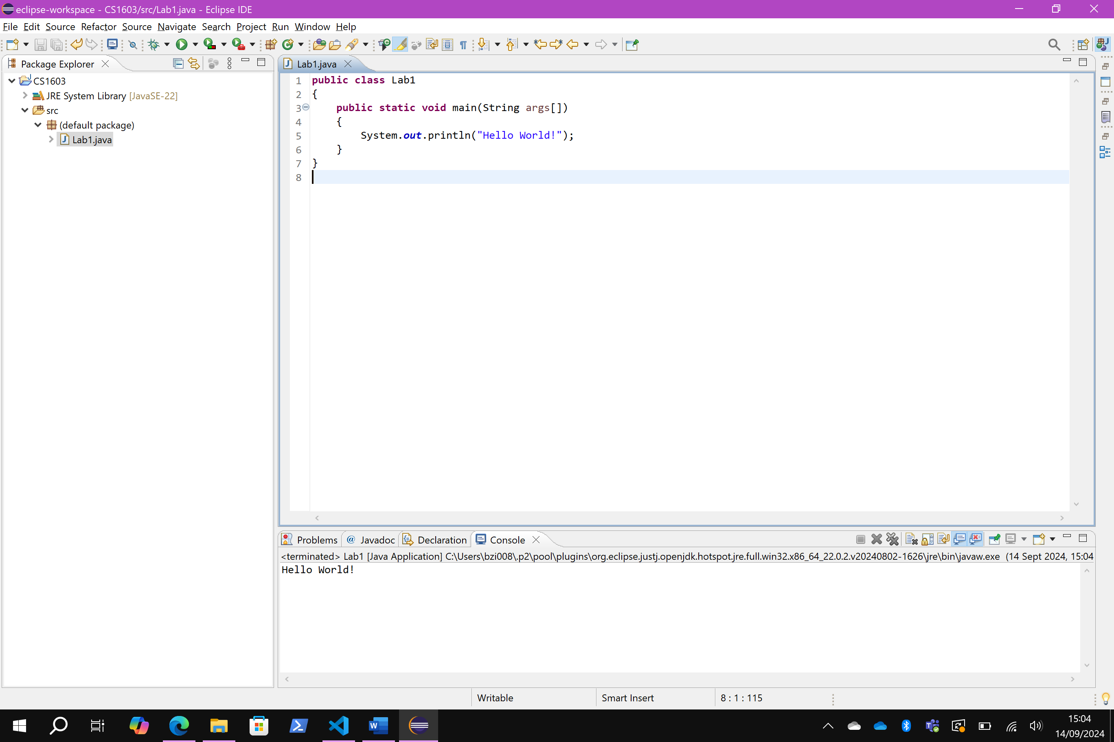

The components of this simple program are as follows:

Class Definition. We will be working with mostly one class to start with. The two keywords public class are always needed to define a class. The name of the class will be added for you by Eclipse. We add our Java code within the class, i.e. within the braces, coloured red in the diagram above. We will cover classes and Object Orientated programming later on in the module.

Main Definition. When we run a program, Eclipse looks for a section of code called main within the class file of our program and if it can find it, will run the code within it. Do not worry at this stage what the sections of the definition of main mean. All we need to know is that any code within the main definition will be executed when we run our program. Code needs to be placed within the braces that follow the definition of main, this is coloured blue in the example above.

System.out.println(). This is a command that simply displays in the Console Window anything that is within the end brackets. In the case above, this is the text “Hello World!”.

Program Statements. Every program statement must end in a semi-colon “;”.

Importing and Backing up Projects

Now that you have created your first “Hello World”, it’s important to understand how your project can be imported and backed up.

Let’s take a more complete open-sourced project and import it to demonstrate the nature of open-sourced programming.

https://github.com/pH-7/Simple-Java-Calculator

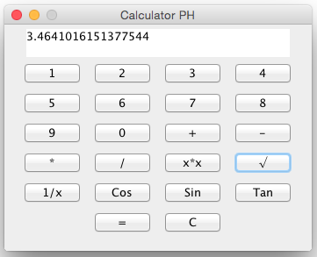
(Note this is directly taken from the GitHub page and it’s run on MacBook)

Start by downloading the project as a ZIP file.
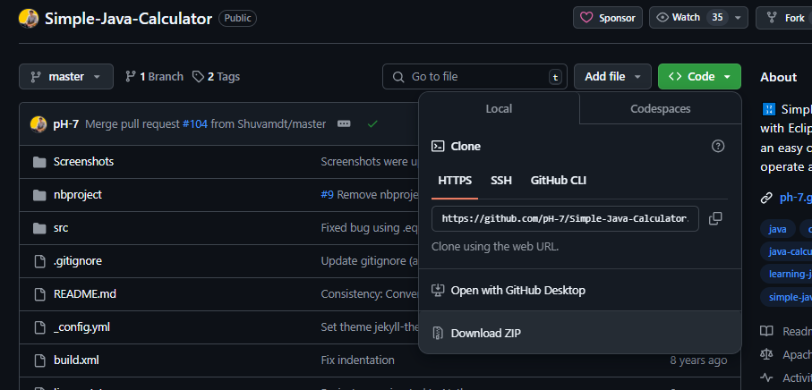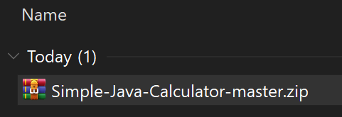

Once you have downloaded the project, make sure the file extension (.zip) is visible for you as this knowing the file extension is an important property when deciding to import projects.

To import this project, in Eclipse go to “File” > “Import” and expand the “General” tab and select “Projects from Folder or Archive”

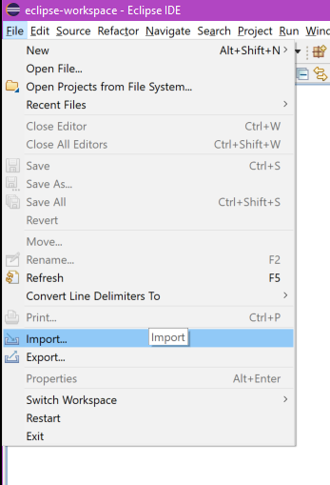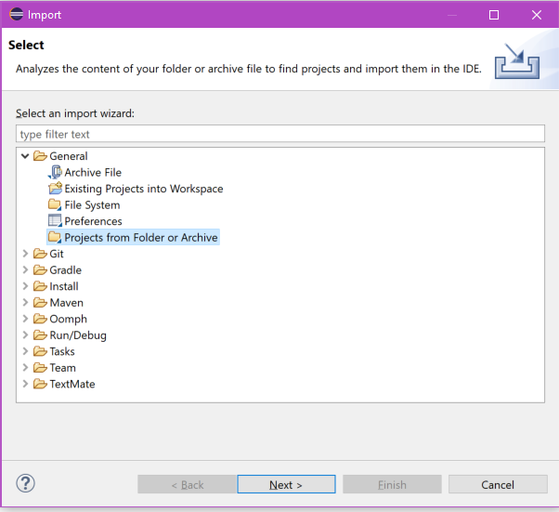

In the final screen, hit “Archive” and select the “Simple-Java-Calculator-master.zip” and then it “Finish”

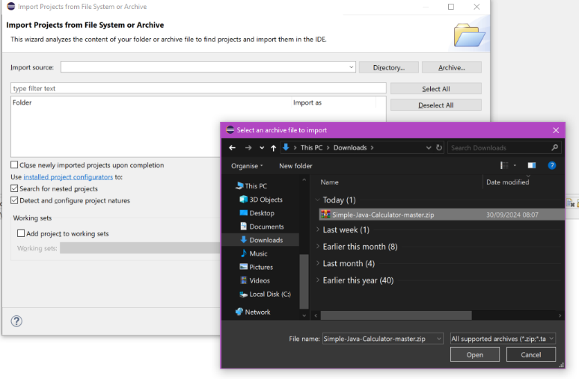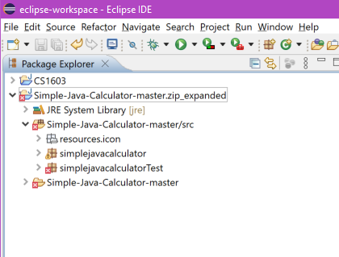

If you have imported the project correctly, it will appear in the “Project Explorer” on the left. However you may notice there are some errors with the project. Inside the “Simple-Java-Calculator-master/src” folder, there is package called “simplejavacalculatorTest” what do you think this is for?

It is file which tests if the program functions works

Nonetheless, for now delete “simplejavacalculatorTest” and run the project!
Let’s make a tiny change to the project, back it up, and share it with our neighbour in the lab to see if our change worked.

Run the program, and notice that the window is called “Calculator PH”. This code for the User Interface is most likely contained within the “UI.java” class.

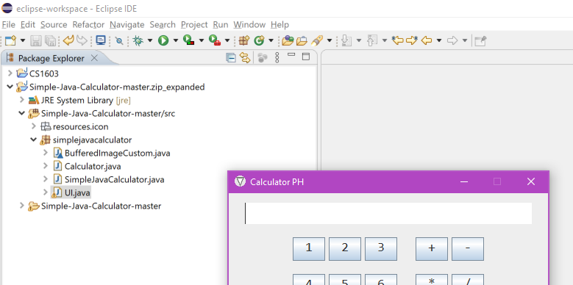

There is a lot of code here, the easiest way to find the window title is to search for it. Hit CTRL+F and enter the exact phrase “Calculator PH” in the “Find” box and search.

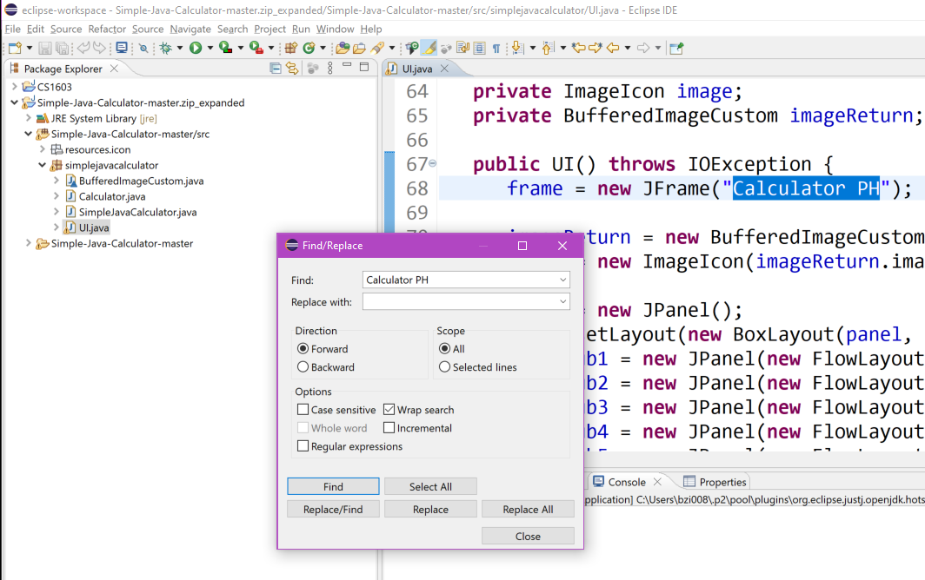

Change the text within the double quotation (“) and replace it with your own name. Run the program again, did it change?

The last step is to now “Export” this version of the project. Go to “File” > “Export” and under “General” select the “Archive File” option.

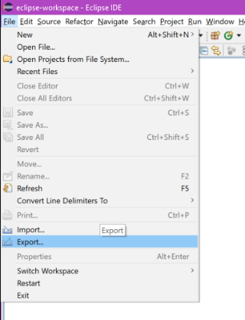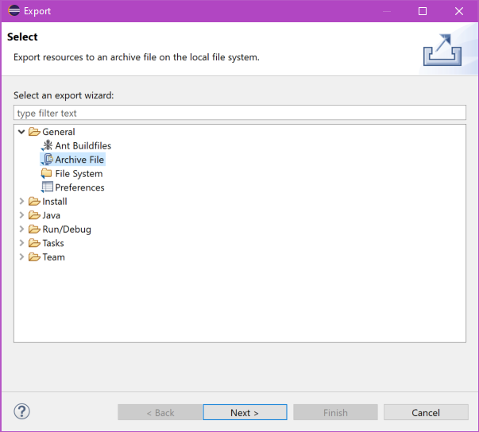

Make sure to tick the “Simple-Java-Calculator-master.zip_expanded”, and provide it with a “Tor archive file” location by hitting Browse

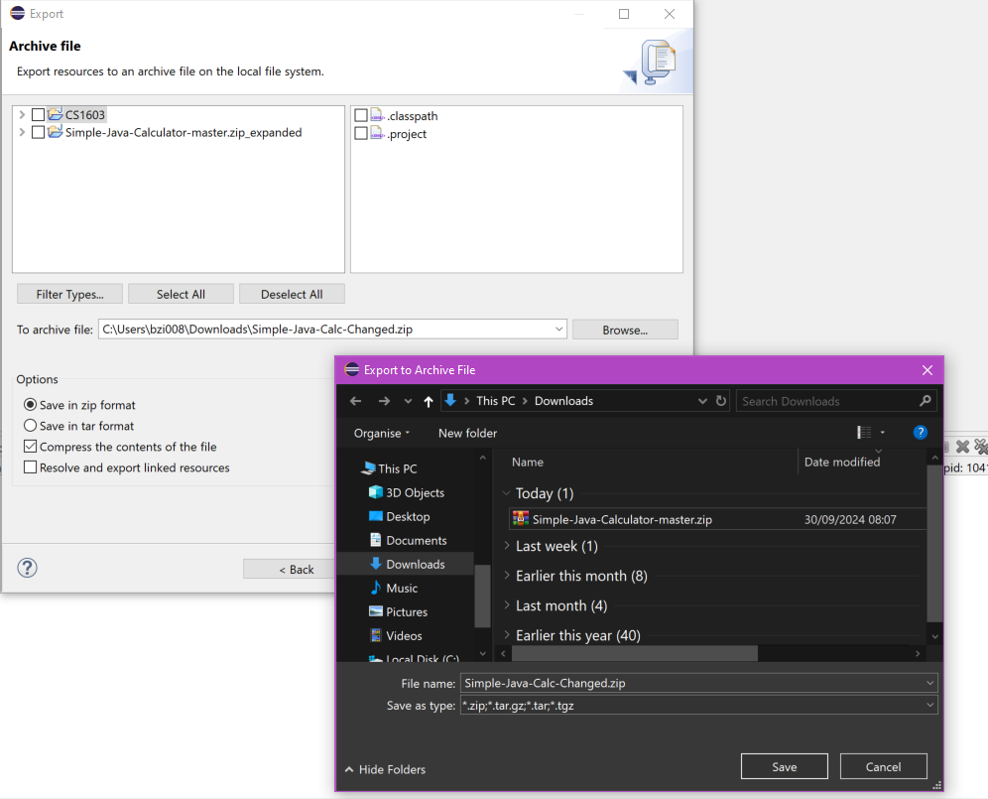

Exercises

The following is a short list of tasks aimed at demonstrating some of the features of Eclipse and Java.

- Change the text from "Hello World!" to something else. Run the program to see the results.

- Remove the semi-colon ";" from the program. Try running it again - what happens?

Syntax error

- Click on the Problems tab next to the Console output Window. This is where Eclipse lists all of the errors in your program. Warnings are possible mistakes (but your program will still run) and Errors need to be fixed before your program will run. Put the semi-colon back - what happens?

- Double click on the partial statement println and then click on the Javadocs tab. Notice that a short help page has been brought up detailing what println does. Now copy and past the first sentence from the Javadocs for the println statement.

Prirnts a String and then terminates the line.

The full Javadocs can be found at:

https://docs.oracle.com/en/java/javase/17/docs/api/index.html

however, this might not mean much at the moment. We will use the Javadocs extensively in some of the later laboratories.

- Copy the whole line that prints to the Console Window and paste it underneath several times. Run the program again - what happens?

Each output is shown on different lines

Experiment with changing the text so that you get different sets of output on each line.

- Delete the "ln" part of some of the printing lines. Run the program again - what happens?

The ones without the “ln” do not write to a new line

- Try using the search and replace (CTRL + F) i.e Edit-Find/Replace to replace all System.out.println statements automatically with System.out.print only statement.

Challenging questions!

- In the “Simple-Java-Calculator-master/src” folder, find the “UI.java” class and change the text of the “Bin” button.

- Change the background colour of the “Bin” button.

(hint: once you find the actual button variable, you can change it’s background by calling the setBackground method)

…setBackground(Color.green);

Completing Worksheets In the Future

Type (or copy and paste) the following program into a new Eclipse Java Project (this assumes that your Java class is called Lab1).

public class Lab1
{
public static void main(String args[])
{
Method1();
Method2();
Method3();
}

public static void Method1()
{
System.out.println("Hello from Method1!!!");
}
public static void Method2()
{
System.out.println("Hello from Method2!!!");
}
public static void Method3()
{
System.out.println("Hello from Method3!!!");
}
}

Run the program and observe the output. The main method runs the code within the three defined methods Method1(), Method2() and Method3() in the order they are called (listed). The process of breaking down a task into a set of sub-tasks is very important and should be something that you start doing for all of your Java programs.

Experiment with changing the text and the order the methods are called. Add extra calls, e.g. call Method2() twice or three times. Create an extra method called Method4() based on one of the others.

You are going to be assessed on some of the material from some of the worksheets (see the study guide and task details for more information). We expect you to structure your code logically using multiple methods, (in a similar manner to the example above), for example if worksheet seven (7) has four (4) questions, you might create methods:

Answers_Q7_1, Answers_Q7_2, Answers_Q7_3, Answers_Q7_4

Structuring your code this way is VERY, VERY important!

